BERNESE MOUNTAIN DOG CLUB OF VICTORIA INC.

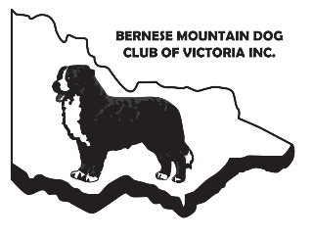
VETERANS PARADE Submission Form
KCC PARK, WESTERNPORT HWY, SKYE
Sunday 12th June 2022 at 9am

VETERAN / GRAND VETERAN SUBMISSION :
Dog’s Name:
Dog’s Pedigree Name (if known):
DOB:
Owner/s names:
Please provide a brief bio of your dog: | Please provide a photo of your dog:

Parade of Veterans – to be held before the BMDCV Championship Show
Please fill out all sections above, save in Word format, and forward to Sheridan via s_a_holmes@hotmail.com no later than Saturday 28th May 2022 referencing “Veterans Parade” and your dog’s name in the subject line. Late requests will not be accepted due to the lead time required for ordering rosettes. Thank you for your understanding.

