BERNESE MOUNTAIN DOG CLUB OF VICTORIA INC.

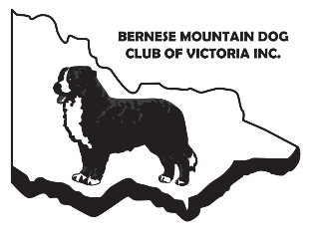
VETERANS PARADE Submission Form
KCC PARK, WESTERNPORT HWY, SKYE
Sunday 9th June 2024 at 9am

VETERAN / GRAND VETERAN SUBMISSION

Dog’s Call Name:
Dog’s Pedigree Name (if known):
DOB:
Owner/s name/s:
Please provide a brief bio of your dog:

Please provide a photo of your dog (at least 100MB) by attaching to your email submission with this form.

Parade of Veterans – to be held before the BMDCV Championship Show
Please fill out all sections above, save in Word format, and forward to Sheridan via bmdcv.pres@gmail.com no later than Friday 10th May 2024 referencing “Veterans Parade” and your dog’s name in the subject line. Late requests cannot be accepted due to the lead time required for ordering rosettes. Thank you for your understanding.

